

**Product Person Name:** Mohit Pinjani

**POD Name:** Product Delivery - POD 2

**Closing Date:** 21st April 2022

**Version:** 01

**Impacted Apps:** Job panel

**KPIs (Key Performance Indicator):** NA

**User Stories**

* As a job panel user, I should be able to add multiple HR to a company so that I am able to manage added jobs better.
* As a job panel user, I should be able to tag HR against the new jobs being added
* As a job panel user, I should be able to filter added jobs based on the name of the HR against whom the job was added
* As a job panel user, when I add a new job in the CRM, I want to send an automated email to the HR of the respective company confirming and notifying that there is a new job added in the job panel.
* As a job panel user, I want to have an automated email sent every 14 days to the HR of the companies asking whether the jobs added are still vacant or filled.

**Feature Details**

As a job panel user, I should be able to add multiple HR to a company so that i am able to manage added jobs better

**Steps**

1. Job Panel
2. Job Panel > Company
3. Under the company tab, there are two tabs Active/ Pending. In both the tabs there is option to add company

**Detailed Description**

1. At present while adding a company the following options are available in Active or Inactive tab

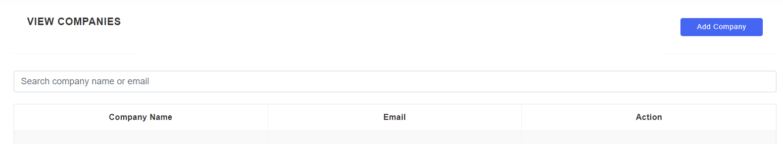

1. A new column needs to be added in the below shown table in the following manner

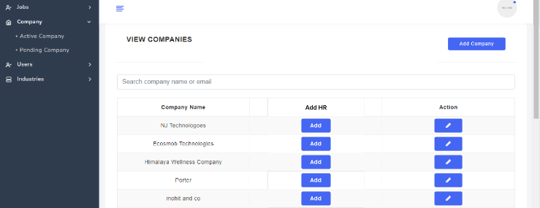

1. The new column added will be named “ Add HR”
   1. In the new column introduced “Add” button will be present
      1. The “Add” button will only be available against a company
   2. When a user click on the “Add” button the following popup will show

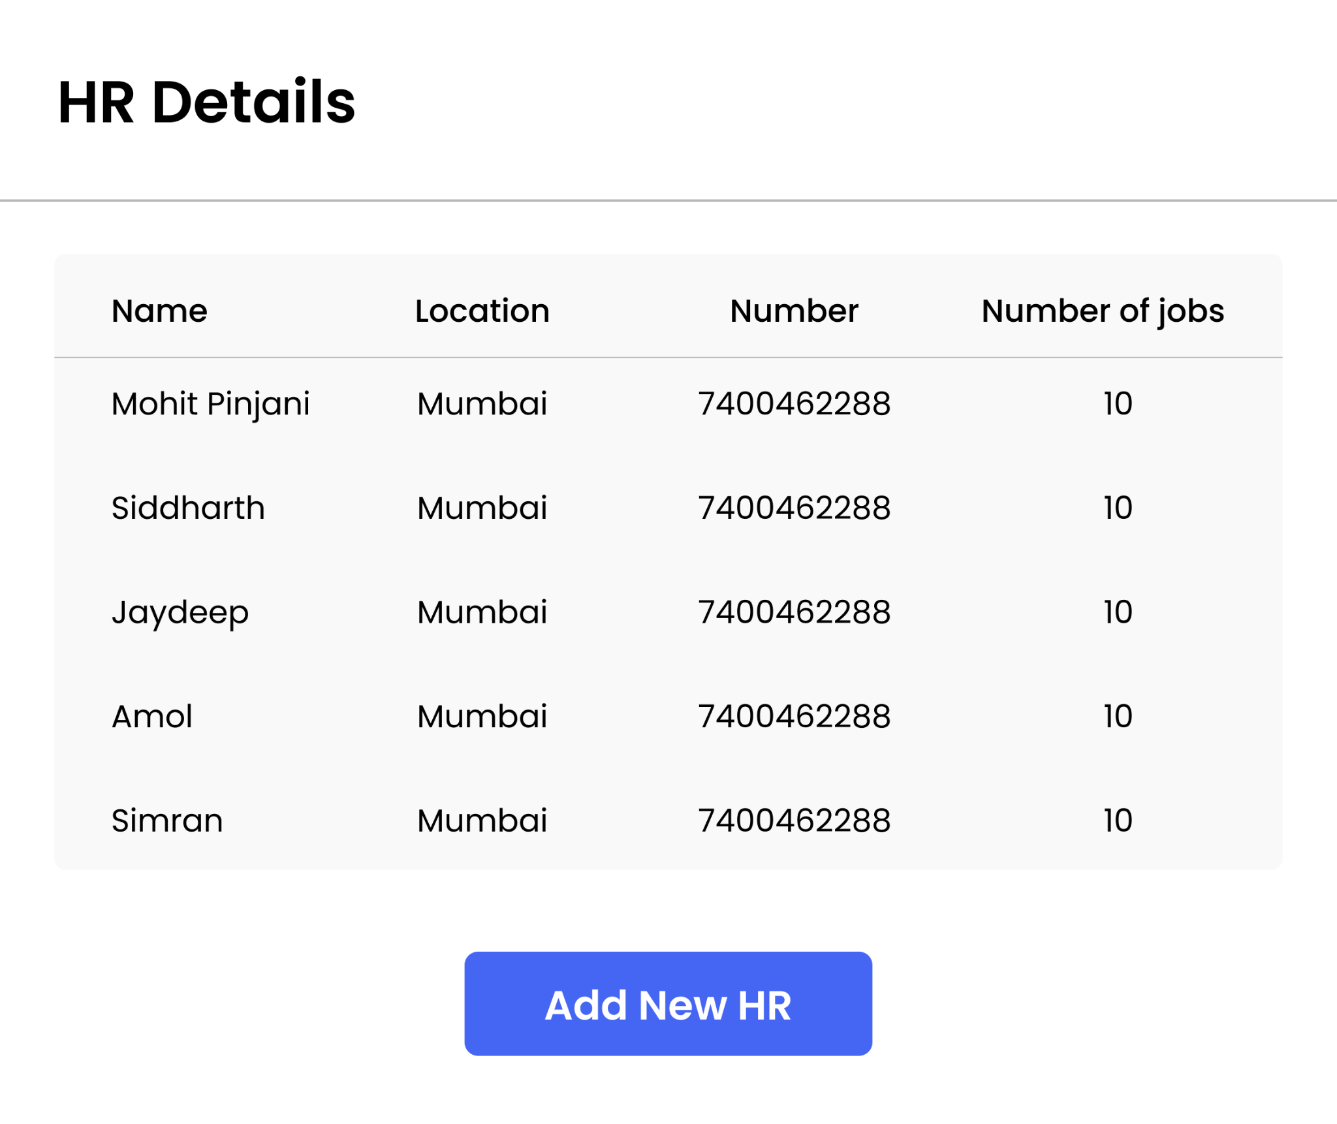

* 1. The popup will show the name of the HR tagged to the company in the table format as shown on the above screenshot. The popup will show the name in the following format
     1. Name - To show name of the HR tagged to the company
     2. Phone Number - To show the phone number of HR tagged to the company
     3. Location - To show the location of the HR
     4. Number of jobs - To show the number of jobs added for the respective HR in the Job Panel
  2. The pop will also have an “Add New HR” button. By clicking on it the following popup will appear

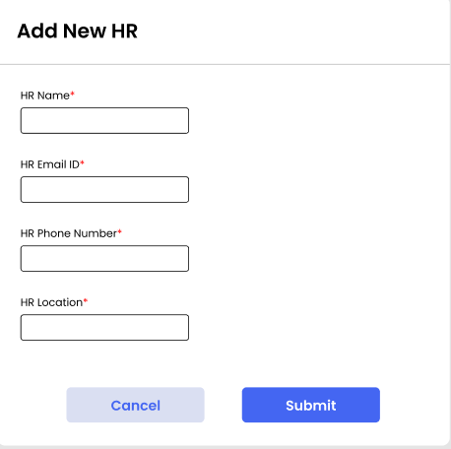

* + 1. In the new popup it will show the following fields
       1. HR Name - A text field to enter name of the HR
       2. HR Location - A text field to enter name of the location
       3. HR Email ID - A text and numeric field to enter mail id of the HR
       4. HR Phone Number - A numeric field to add number of HR
          1. It will only allow numeric digits
          2. It will not allow phone numbers more than 10 digits. In case the number is more than 10 digits, it will show the following message - “ Please enter correct phone number”
       5. All the fields are mandatory fields
       6. Submit - By clicking on this, all the fields entered will be saved against the company.
          1. The popup will close
       7. Cancel - by clicking on this the popup will close and none of the fields entered will be saved

**Changes on the Information Displayed under Active & Pending Companies**

1. The table the Pending companies will show only three fields
   1. Company Name
   2. Action
   3. HR
   4. The three fields will be shown in the following manner

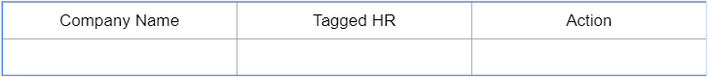

1. The search will allow the users search basis
   1. Company name
   2. HR Name
   3. Phone Number
   4. HR Email Id

**Acceptance Criteria**

1. All the other features in Active & Pending companies will function as they are.

**Feature Details**

As a job panel user, I should be able to tag HR against the new jobs being added

**Steps**

1. Job Panel
2. Job Panel > Jobs
3. Under the Jobs tab, there are two options available, Active Job & Pending Jobs. In both the sub tabs Add Jobs button is available

**Detailed Description**

1. At present while adding new job the following window shows

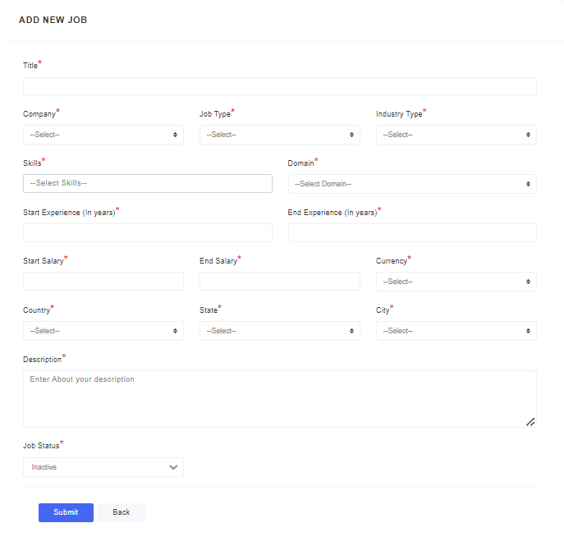

1. Now, a new dropdown field needs to be added in the following manner

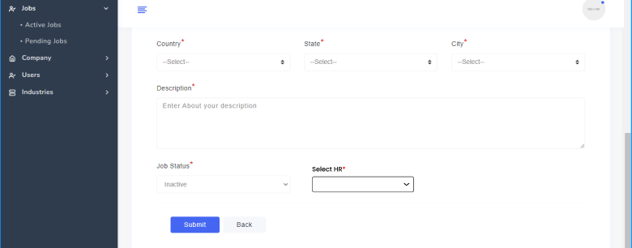

1. The new field added will be a dropdown which will show name of the tagged HR in the following manner

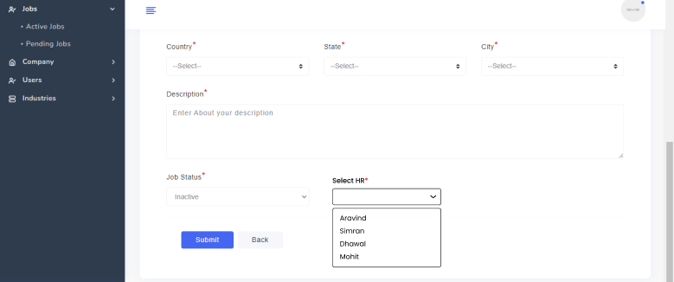

* 1. The user will only be able to select one HR name at a go
  2. This is a mandatory field
  3. Once the user clicks the Submit button
     1. All the details will be saved as defined
     2. The new HR field added will also be saved against the job added
     3. A mail will be triggered to HR for checking if the job is active or inactive

**Acceptance Criteria**

1. The changes made in form will also reflect in Edit form present against the jobs
2. All the features will function as defined

**Feature Details**

As a job panel user, I should be able to filter added jobs based on the name of the HR against whom the job was added

**Steps**

1. Job Panel
2. Job Panel > Jobs
3. Under the Jobs tab, when a user clicks on active jobs he/she is shown multiple filter options.

**Detailed Description**

1. At present the filter shown the following options

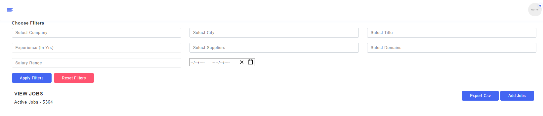

1. A new filter for HR needs to be introduced in the following manner

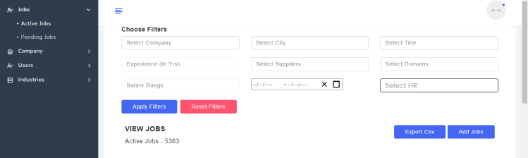

* 1. The new HR filed will be searchable dropdown which will HR name based on
     1. Name being entered
     2. Mobile number of HR
     3. Email ID of HR
  2. When filter is applied and HR name is selected all the companies and jobs associated in the table. All the information displayed in the table will remain the same.

**Acceptance Criteria**

1. The new filter being introduced will work in combination with other filter fields

**Feature Details**

As a job panel user, when I add a new job in the CRM, I want to send an automated email to the HR of the respective company confirming and notifying that there is a new job added in the job panel.

**Detailed Description**

1. As for now, when a new job is added to the CRM, no notification emails are sent to the respective HR of the companies.
2. We will be adding mail triggers to be sent to
   1. HR
   2. Placements Team

**First Action Trigger for Mailers**

1. As we click on Add Jobs in Job Panel, a popup opens which shows the following information

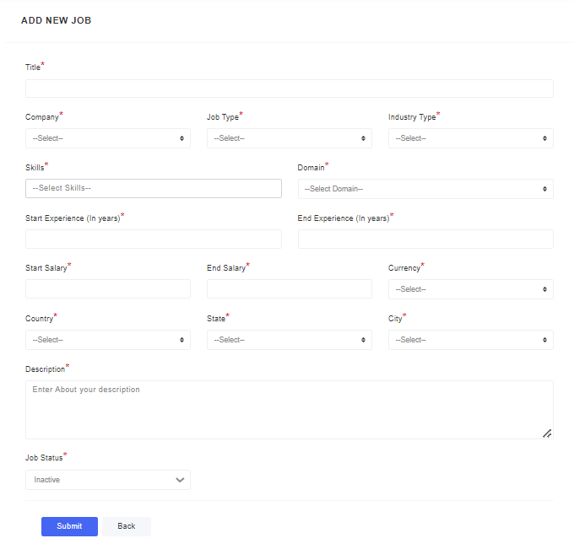

1. When an Admin user on Job Panel adds jobs, if these two conditions are met then a mail is triggered to the HR Tagged to the Company to which job is being added
   1. Job Status - Active
   2. Submit - If Admin type user clicks on the submit button
2. Also, in a job inactive bucket is made active, then a mail will be triggered to the HR tagged with the company against which the job is added
3. Email would contain 2 CTA “YES” and “NO”. Based on the CTA clicked a mail will be triggered to the back to the placements team and the HR
   1. Also, call to action response will be captured in backend against the job
      1. If HR clicks yes - The job will remain in active bucket
      2. If HR clicks No - The job will move from active to inactive bucket

**Acceptance Criteria**

1. There would be a single group Email ID created for all the multiple users using the job panel CRM through which all the email communication will be done.
2. The mail will be triggered to respective HR tagged to that respective job.
3. If using the edit option in Job Panel, the HR name is updated from the previously selected the same will reflect in Tagged HR field under Active & Pending Companies.

**Feature Details**

As a job panel user, I want to have an automated email sent every 14 days to the HR of the companies asking whether the jobs added are still available or vacant.

**Detailed Description**

1. Every 14 days, an automatic email reminder will be sent to the HR of the companies to know whether the job that was added to the CRM in the active list is still available or filled.
   1. Day 1 → the day once the job is added to the active list
2. 14 days would be counted including the day the job has been added to the active list.
3. Email would contain 2 CTA “YES” and “NO”. Based on the CTA clicked, a mail will be triggered to the back to the placements team
   1. Also, call to action response will be captured in backend against the job
      1. If HR clicks yes - The job will remain in the active bucket.
      2. If HR clicks No - The job will move from active to inactive bucket

**Acceptance Criteria**

1. Reminder emails will be sent every 14 days.
2. Reminder emails will not be sent for inactive jobs in the list. .
3. Reminder email would be sent through the same email to the HR that we are using when we are adding a job in the CRM.

**Mail Content & Zeplink -** <https://docs.google.com/spreadsheets/d/1-LKNBYpOPeFXhszzzoUB9VmbYFmOKwEexujSNUA2u_Y/edit#gid=679432083>

**Email Content**

**Email confirmation for when the job is added to the active list**

**Main Heading Text**

A new job has been added

**Body Text**

Hello,

We have added the following job to our panel.

Job Profile → Required details

Job Description → Required details

Date → When the job was added to the active list

Location → Required details

**Email reminder for every 14 days**

**Main Heading Text**

“Reminder Email”

**Body Text**

Hello,

We had added this job to our job panel on 5th March 2022 as per your discussion with our Placement team.

We just wanted to check whether this job is still acceptingapplications or has been closed.

Job Profile → Required details

Job Description → Required details

Date → When the job was added to the active list

Location → Required details